Lead Gen Business Queries

1. What query would you run to get the total revenue for March of 2012?

SELECT MONTH(charged_datetime) as month, SUM(amount)

FROM billing

WHERE MONTH(charged_datetime) = 3;

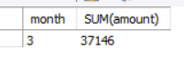

2. What query would you run to get total revenue collected from the client with an id of 2?

SELECT client_id, SUM(amount)

FROM billing

WHERE client_id =2;

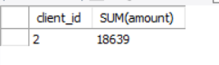

3. What query would you run to get all the sites that client=10 owns?

SELECT sites.domain_name as website, clients.client_id

FROM sites

JOIN clients ON clients.client_id = sites.client_id

WHERE clients.client_id = 10;

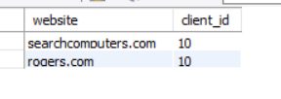

4. What query would you run to get total # of sites created per month per year for the client with an id of 1? What about for client=20?

SELECT sites.client_id, COUNT(sites.domain_name) as number_of_websites, MONTHNAME(created_datetime) as month_created, YEAR(created_datetime) as year_created

FROM sites

WHERE sites.client_id = 1

GROUP BY MONTHNAME(created_datetime);

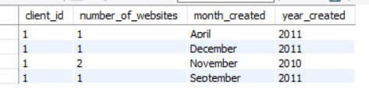

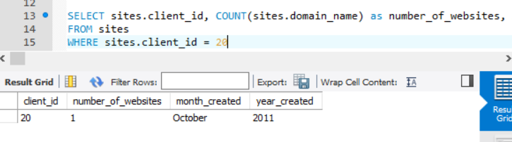

5. What query would you run to get the total # of leads generated for each of the sites between January 1, 2011 to February 15, 2011?

SELECT sites.domain_name AS website, COUNT(leads.leads_id) as number_of_leads, leads.registered_datetime

FROM sites

JOIN leads ON sites.site_id = leads.site_id

WHERE leads.registered_datetime BETWEEN '2011-01-01' AND '2011-02-15'

GROUP BY sites.domain_name;

GET THIS RESULTS

6. What query would you run to get a list of client names and the total # of leads we've generated for each of our clients between January 1, 2011 to December 31, 2011?

SELECT CONCAT(clients.first_name," ",clients.last_name) as client_name, COUNT(leads.leads_id) as number_of_leads

FROM clients

JOIN sites ON clients.client_id = sites.client_id

JOIN leads ON sites.site_id = leads.site_id

WHERE DATE(registered_datetime) BETWEEN '2011-01-01' AND '2011-12-31'

GROUP BY CONCAT(clients.first_name," ",clients.last_name);

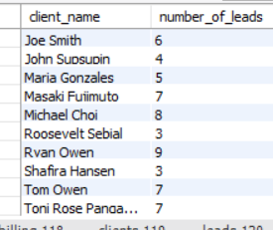

7. What query would you run to get a list of client names and the total # of leads we've generated for each client each month between months 1 - 6 of Year 2011?

SELECT CONCAT(clients.first_name,' ',clients.last_name) as client_name, COUNT(leads.leads_id) as number_of_leads, MONTHNAME(leads.registered_datetime) as month_generated

FROM clients

JOIN sites ON clients.client_id = sites.client_id

JOIN leads ON sites.site_id = leads.site_id

WHERE MONTH(leads.registered_datetime) BETWEEN 1 AND 6

AND YEAR(leads.registered_datetime) = '2011'

GROUP BY CONCAT(clients.first_name," ",clients.last_name);

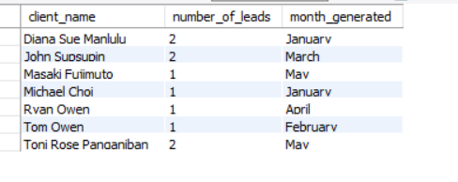

8. What query would you run to get a list of client names and the total # of leads we've generated for each of our clients' sites between January 1, 2011 to December 31, 2011? Order this query by client id.  Come up with a **second** query that shows all the clients, the site name(s), and the total number of leads generated from each site for all time.

9. Write a single query that retrieves total revenue collected from each client for each month of the year. Order it by client id.

SELECT CONCAT(clients.first_name,' ',clients.last_name) as client_name, SUM(billing.amount) as Total_Revenue, MONTHNAME(billing.charged_datetime) as month_charge, YEAR(billing.charged_datetime) as year_charge

FROM clients

JOIN billing ON clients.client_id = billing.client_id

GROUP BY billing.amount

ORDER BY clients.client_id;

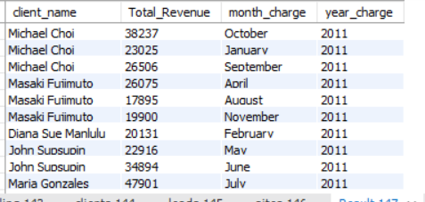

10. Write a single query that retrieves all the sites that each client owns. Group the results so that each row shows a new client. It will become clearer when you add a new field called 'sites' that has all the sites that the client owns. (HINT: use GROUP_CONCAT)